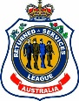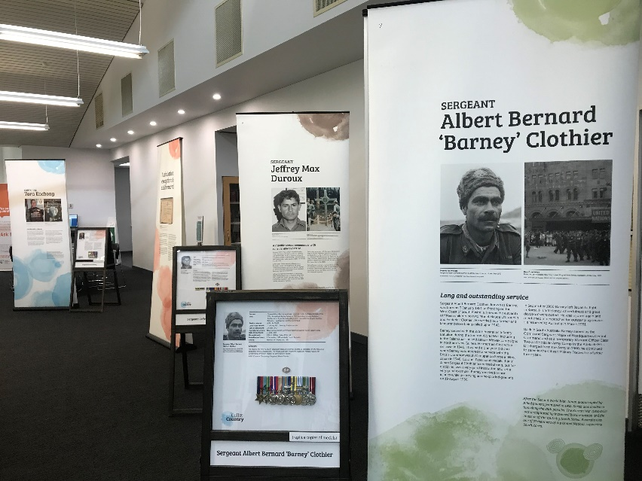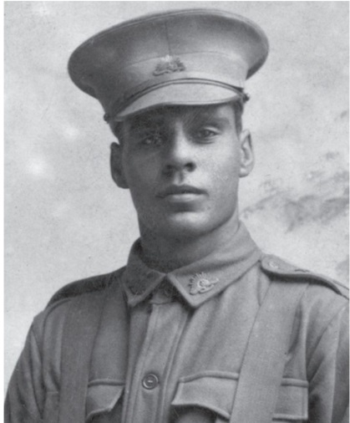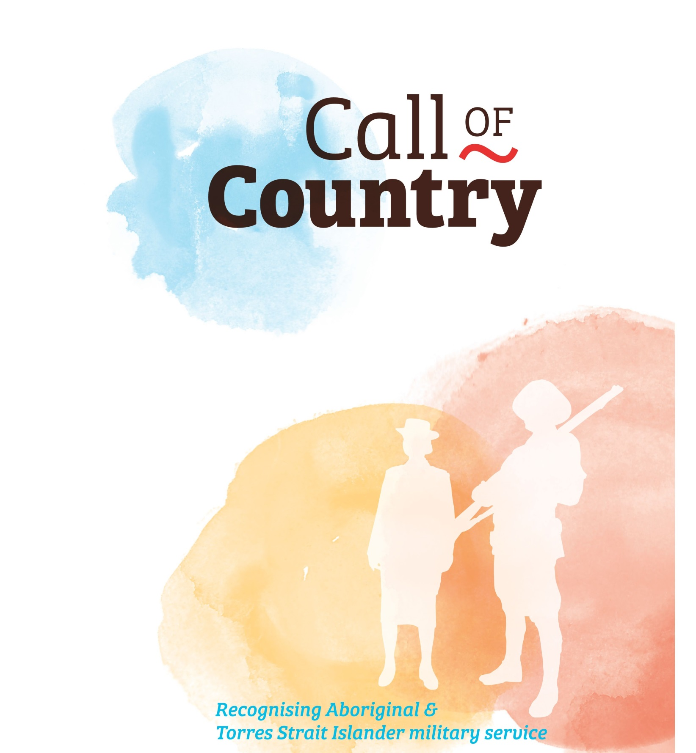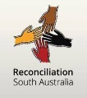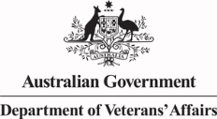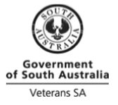

**Where:**

**When:**

**Contact**:

Learn more about aboriginal and indigenous Australians who have served with the Australian Defence Forces.

First launched in 2015, this travelling exhibition recognises Aboriginal & Torres Strait Islander military service. Despite discrimination in everyday life and in national enlistment policy, Aboriginal and Torres Strait Islander people volunteered and served in all conflicts in which Australia has been involved. The service of the ten people in this display extends from the First World War to Afghanistan. Some returned from battle, some were injured, some were taken prisoner and others were killed in action. Viewers will be moved by their courage and achievements.

*Call of Country* consists of seven double-sided pull-up panels and five double-sided A-frames displaying the replica medals awarded to the ten people cited.

**E X H I B I T I O N**

**A History Trust of South Australia travelling display P**roject supported by the ANZAC Day Commemoration Council; Dept of Veterans Affairs; Reconciliation SA; RSL (SA); Veterans SA; Vietnam War Memorial Committee and managed by the Register of Aboriginal Veterans of SA (RAVSA) with the support of Reconciliation SA