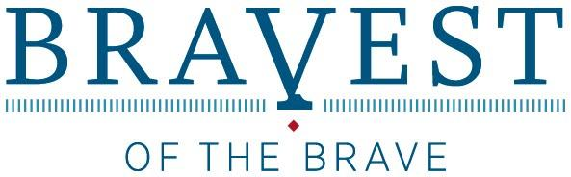

ORGANISATION in PLACE is to host the History Trust/Veterans SA’s travelling exhibition Bravest of the Brave at ADDRESS OF LOCATION from DATES & YEAR
The display tells the story of eight South Australian men who were awarded the Victoria Cross for their heroic deeds during the First World War (1914-18). Some were born or educated in South Australia; some enlisted here, while others lived here either before or after the war.
Bravest of the Brave consists of seven doubled-sided pop-up banners displaying text and photographs and four wooden crates which act as plinths to display the framed citations and replica medals belonging to the eight men.
The Victoria Cross is the British and Commonwealth’s armed forces’ most coveted award, their supreme decoration for gallantry, under enemy fire. Only 1,356 medals have been awarded since its introduction in 1856.
The eight men were Arthur Blackburn, Phillip Davey, Roy Inwood, Jørgen Jensen, John Leak, Arthur Sullivan, Lawrence Weathers and James Park Woods. They came from all walks of life, both from the city and from the country. Among them, there was a lawyer and a banker used to office work in civvy street as well as a former miner, teamster and vigneron more accustomed to getting their hands dirty.
Although it serves to commemorate their bravery and sacrifice, Bravest of the Brave nevertheless attempts to also show how the war affected these men for the rest of their lives – most were hampered by illness and restlessness as well as being generally reticent about their bravery.
It is personal story of eight ordinary men who on one day of their lives, under extraordinary circumstances, demonstrated extraordinary heroism for their comrades and country.
The exhibition gives an introduction to the First World War and South Australia’s part in the conflict, originally known as the Great War fought in Europe from 1914-1918; a brief history of the Victoria Cross, a short profile of each of the eight men and a final concluding section.
One of the many projects that was prepared worldwide to commemorate the centenary of the First World War in 2014, Bravest of the Brave is available from the History Trust of South Australia to travel to schools, RSL clubs, museums, libraries, aged care facilities, community centres etc. There is also a schools resources kit.
Photographs of the exhibition displayed at various venues including its launch by the Hon Jack Snelling MP in April 2012 can be seen here
http://www.flickr.com/photos/communityhistorysa/collections/72157631448398898/
For more information please call 8203 9888 or email staff@history.sa.gov.au (OR CONTACT DETAILS OF EXHIBITION VENUE)

